

XTCC™ 4-YEAR 100% PRINCIPAL PROTECTED

INVESTMENT

Version 1.1 | November 2023

Table of Contents
The XTCC 4-Year Principal Protected Investment 2
Highlights 3
How Does it Work? 3
Carbon Market Historical Returns 4
Mobilising capital markets to protect Earth's biosphere 5
What Might You Get Back? 6
Frequently Asked Questions 6

DISCLAIMER
This document contains forward-looking statements. Forward-looking statements often include words such as “anticipate,” “expect,” “intend,” “plan,” “believe,” “continue,” or similar words in connection with discussions of future operating or financial performance. The forward-looking statements are based on the Directors’ and, where relevant, the Issuer’s current expectations and assumptions regarding commercial performance, the economy, and other future conditions, circumstances, and results. As with any projection or forecast, forward- looking statements are inherently susceptible to uncertainty and changes in circumstances. The results may vary materially from those expressed or implied in its forward-looking statements. The Notes may not be a suitable investment for all investors. Each potential investor in the Notes must determine the suitability of that investment considering its own circumstances.

Each potential investor may wish to consider, either on its own or with the help of its financial and other professional advisers, whether it:

- has sufficient knowledge and experience to make a meaningful evaluation of the Notes, the merits and risks of investing in the Notes, and the information contained or incorporated by reference in this Investment Memorandum or any applicable supplement;
- has access to, and knowledge of, appropriate analytical tools to evaluate, in the context of its particular financial situation, an investment in the Notes and the impact the Notes will have on its overall investment portfolio;
- has sufficient financial resources and liquidity to bear all of the risks of an investment in the Notes, including Notes where the currency for principal or interest payments is different from the potential investor’s currency;
- understands the terms of the Notes thoroughly and is familiar with the behaviour of financial markets; and
- is able to evaluate possible scenarios for economic, interest rate, and other factors that may affect its investment and its ability to bear the applicable risks.

Legal investment considerations may restrict certain investments. The investment activities of certain investors are subject to legal investment laws and regulations or review or regulation by certain authorities. Each potential investor should consult its legal advisors to determine whether and to what extent (1) Notes are legal investments for it, (2) Notes can be used as collateral for various types of borrowing, and (3) other restrictions apply to its purchase or pledge of any Notes. Financial institutions should consult their legal advisors or the appropriate regulators to determine the appropriate treatment of Notes under any applicable risk-based capital or similar rules.

This document and its content are prepared by Sustainable Capital PLC. The information presented here does not constitute investment advice or a recommendation and is not an invitation to invest. Nothing in this document is intended to nor will create any binding obligation on anyone. Applications should only be made based on the Pricing Supplement and Listing Particulars, which are available from authorised distributors. Prospective investors should be capable of evaluating the risks and merits associated with this investment and have sufficient resources to bear any losses. No representation or warranty, express or implied, is made by Sustainable Capital PLC or any of its associates, affiliates, or subsidiary companies or any of their respective directors, officers, employees, advisers, representatives or agents, or any other person or entity as to the fairness, adequacy, accuracy or completeness of the information or opinions contained in this document or any written or oral information made available to any interested party. No liability whatsoever is accepted by any such person in relation to any such information or opinion.

Past performance is no guarantee of future returns.

The XTCC 4-Year Principal Protected Investment

XTCC™ is the world’s first investment product for high-integrity carbon credits sourced from verified, renewable energy projects focused on the drive for net zero.

The XTCC Principal Protected Investment is a four-year investment designed to offer a market first: the first-ever principal-protected high-integrity carbon credit investment. XTCC is ideal for most investors as it offers both principal protection at maturity and the potential to benefit from the demand for the net zero world.

Highlights

➹ 100% principal protection at maturity
➹ Uncapped participation in the rise of the XTCC price
➹ Uncorrelated to equity and debt markets and other commodities
➹ No derivatives, adhering to simplified product guidelines under MiFID rules
➹ Eligible for direct investment or through appointed distributors, including ISA and other tax- efficient wrappers
➹ Plug & Play asset class exposure for existing client portfolios
➹ No annual charges

XTCC only invests in authenticated and verified high-integrity carbon credits. The demand for high- integrity carbon credits is expected to grow by 15x by 2030¹.

To provide for the principal protection, approximately 80% of the proceeds of the Note will be deposited with Investment Grade Money Market Fund (rated AAAm) the “Principal Protection Provider”. The actual amount will depend on the prevailing rates, but as of the date of the Investment Memorandum, the amount would be approximately 80%.

How Does it Work?

The XTCC Four-Year Principal Protected Investment is a straightforward structure. XTCC Principal Protected product is composed of two parts:

Principal Protection
XTCC invests sufficient funds to ensure a 100% return is delivered at the end of the term. The Investment Grade Money Market Fund (AAAm rated) investment offers the best possible protection at the lowest cost.

¹Blaufelder, et al. (2021 January). A Blueprint for Scaling Voluntary Carbon Markets to Meet the Climate Challenge. McKinsey Sustainability.
<https://www.mckinsey.com/capabilities/sustainability/our-insights/a-blueprint-for-scaling-voluntary-carbon-markets-to-meet-the-climate- challenge>

High-Integrity Carbon Credits Performance
XTCC invests in high-integrity carbon credits which are sourced from verified and audited projects that comply with the CDM Protocols and align with the industry standard definitions of high-integrity carbon credits.

The two elements together are secured assets in favour of the investors. At maturity, the repayment amount consists of the principal protection plus the increased value of the portfolio of high-integrity carbon credits. No derivatives are used in the XTCC Principal Protected Investment product.

Carbon Market Historical Returns

The Kyoto Protocol introduced the concept of emissions trading, a new type of market (and asset) that created the carbon credit as a commodity that could be bought, sold, saved, or traded. The compliance market for carbon credits and Emission Trading Systems (ETSs) have sprung from this concept. In short, emissions trading allowed countries with leftover credits to monetise their remaining assets by selling them to other countries, especially those that pollute above their allotment and have a need to purchase credits to make up the difference. This national carbon offsets system created by the Kyoto Protocol is fundamental to the compliance carbon market, most commonly known as the ETS or European Union Allowance (EUA).

This “national offset” scheme has proven to be very well regarded, efficient, and impressive for investment purposes. The prices on the ETS market reflect the trend that the political and social demand for carbon reduction and the drive for a net zero world has become higher on the global agenda.

Since 2014, the price of carbon credits has seen an annualised 150% increase per annum (from 5.91 Euros to 81.88 Euros, a roughly 14-fold increase) and a nearly 40% per annum average increase over the last five years.

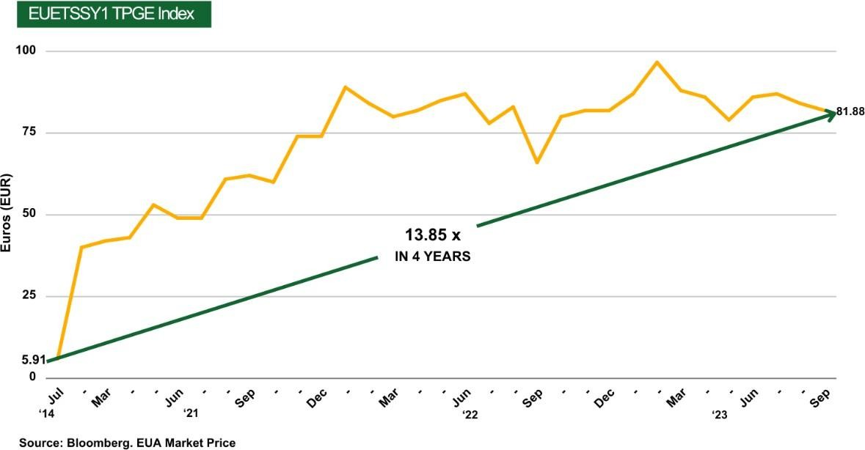

The above is based on the performance of the established ETS market. According to research from Bain, McKinsey, Shell, BCG, and many others, the demand for high-integrity carbon credits may reflect a similar growth as the demand for net zero offsetting becomes more important in the public agenda.²³⁴⁵

Mobilising capital markets to protect Earth's biosphere

The market for voluntary carbon credits has tripled from about $300 million in 2020 to more than $1 billion in 2021⁶. By the end of 2022, the estimated total market was more than $2 billion⁷.

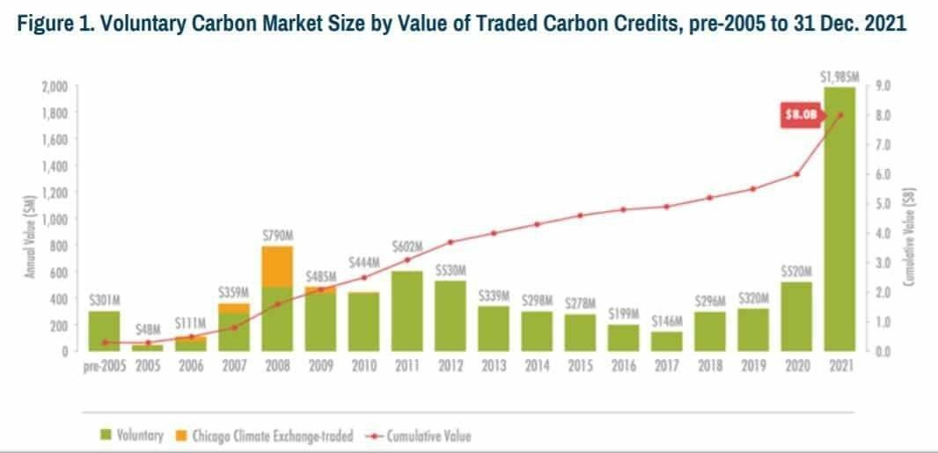
Bain, BCG, Shell, Barclays, and the Norwegian Sovereign Wealth Fund, amongst many others, predict the market is about to explode; by 2030, estimates range from between $10 billion to $50 billion in size (and one noted outlier estimates at $180 billion).⁸ If the consensus is only half right, that is more than a 10x increase in value in the next seven years.
Source: [missing source]

²Graf, Christian, et al. (2023, 9 August). Voluntary Carbon Markets Present New Revenue Streams for Banks. Bain and Company.
<https://www.bain.com/insights/voluntary-carbon-markets-present-new-revenue-streams-for-banks-infographic/>
³Blaufelder, Op cit.
⁴Shell Global (2023, 19 January). Shell and BCG’s New Report Shows Accelerated Growth in Carbon Markets.
<https://www.shell.com/business-customers/trading-and-supply/trading/news-and-media-releases/shell-and-bcgs-new-report-shows- accelerated-growth-in-carbon-markets.html>
⁵Prosborg-Smith, Anders, et al. (2023, 19 January) The Voluntary Carbon Market is Thriving. Boston Consulting Group.
<https://www.bcg.com/publications/2023/why-the-voluntary-carbon-market-is-thriving>
⁶MSCI (2022, 8 June) Introducing the Carbon Market Age . Morgan Stanley Capital International.
<https://www.msci.com/www/blog-posts/introducing-the-carbon-market/03227158119>
⁷L. Jennifer, (2022, 5 August) Real Voluntary Carbon Market Value is 2 Billion. CarbonCredits.com.
<https://carboncredits.com/real-voluntary-carbon-market-value-is-2-billion/>
⁸Blaufelder, Op cit.

What Might You Get Back?

The table below shows some examples of how much an investment would be worth at the final maturity date, given different levels of growth in the XTCC price based on an initial investment of 100,000 and an uncapped participation rate of 20% (estimated as at the date of this document):
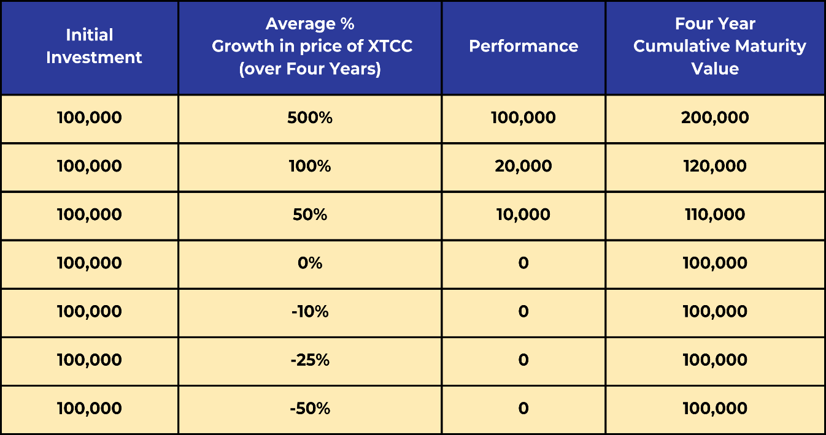
Please note that the above illustration is an example and is not intended to indicate potential or future returns

Frequently Asked Questions

What does XTCC stand for?
XTCC stands for eXchange Traded Carbon Credits.

How is the price of XTCC calculated?F
XTCC pricing is calculated based on trading prices combined with standard data sources to determine the net asset value and is published weekly on Bloomberg and the relevant exchange(s).

What is a ‘plug & play’ asset class?
The term “plug and play” refers to the possibility of adding diversification to a portfolio in a low-cost and simplified manner.

Is there a secondary market?
Yes, although this is a fixed-term product, investors should expect to hold to maturity. However, the product is listed, and whilst there may be a secondary market, it is subject to market conditions and the risk factors set out in the Investment Memorandum.

Can I redeem my investment early?
Investors should expect to hold to maturity, typical to all fixed-term structured products. The fact that the XTCC Principal Protected products are listed means that if a secondary market develops, investors may be able to sell their investment in part or in full. However, the price is uncertain, and the normal risks associated with secondary market investments apply.

Where is XTCC incorporated?
XTCC is incorporated in England. XTCC is part of the award-winning Sustainable Capital issuance platform. Sustainable Capital PLC (recognised on the NASDAQ Sustainable Bond Network) was one of the world’s first green bond issuance platforms and offers a flexible, quick- to-market solution for green and sustainable investments.

What security is there for my investment?
The assets are secured for investors under an English Law trust agreement. Independent Trustees, Truva Trust Corporation PLC, act as the noteholder trustee and security trustee. More details can be found in the Listing Particulars.

What is the credit rating of the principal protection?
The Principal Protection Provider is Investment Grade Money Market Fund. Principal protection is provided by investing in the AAAm-rated investment grade money market fund.

Do investors get yearly returns in XTCC 4-Year Principal Protected Investments?
No. XTCC is a performance-related product and pays out at maturity. Investors will receive their principal and the net asset value of the high-integrity carbon credits at maturity.

- How does the Maturity Payment for the XTCC 4-Year Principal Protected Investment work? XTCC is structured to provide 100% principal protection at maturity and participation in the increase in the price of high- integrity carbon credits. At maturity, the principal protected amount and the final realisable sale value of the carbon credits are paid to investors.

Are the returns capped?
The upside is uncapped. At maturity, investors will receive a defined percentage of the upside of the movement in price. Because a portion of the investment is invested to provide principal protection, the participation in the price increase is adjusted accordingly. The example above gives different potential return scenarios based on the movement in price from the date of investment.

How does XTCC verify its sources of high-integrity carbon credits?
XTCC sources high-integrity carbon credits that must meet the 10 Core Carbon Principles as defined by the Integrity Council for Voluntary Carbon Markets (ICVCM)⁹ and are also assessed against compliance with ISO ISO14064 requirements. XTCC will only purchase verified and audited high-integrity carbon credits that are in accordance with the United Nations Framework Convention on Climate Change (UNFCCC) recognised CDM protocols for pre- approved project types. High-integrity credits must meet further requirements, including additionality and co-benefits.

What type of projects does XTCC source their carbon credits from?
XTCC only invests in high-integrity carbon credits sourced from projects including solar, wind, hydropower, biogas, biomass, and biomethanation. All projects have been operational since at least 2016 and meet the latest industry requirements for carbon credit production, including the Carbon Offsetting and Reduction Scheme for International Aviation (CORSIA). XTCC

9 invests in the asset class, not the project; there is no project risk.

ICVCM.org. (2023 July). The Core Carbon Principles. The Integrity Council for The Voluntary Carbon Market <https://icvcm.org/the-core- carbon-principles/>

